Name:

ID:

M5 Exam 1

<https://repl.it/@enaard/Python-3>

1. Consider the following:

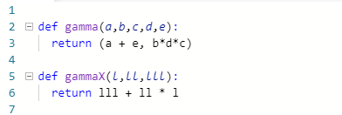

How many parameters does the gammaX function have?

|  |  |
| --- | --- |
| 0 | 1 |
| 2 | 4 |
| 3 | 5 |

2) What is the sum of the first element of [1+1j,2,3,4] and the last element of range(1)?

|  |  |
| --- | --- |
| 3 | 2 |
| 3 + 1j | 0 |
| 2+1j | 0 + 1j |
| None | 1+1j |
| j | 4 |

3) Which of the following has a int value?

|  |  |
| --- | --- |
| True | ‘13’ |
| “”Integer””” | 1 % 2 |
| “Int” | 1 == 2 |

4) Which of the following correctly sums the “a1” and “a2” keys of myDic?

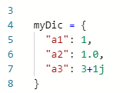

|  |  |
| --- | --- |
| “a1” + “a2” | myDic(a1) + myDic(a2) |
| myDic[“a1”] + myDic[“a2”] | myDic(“a1”) + myDic(“a2”) |
| myDic{a1} + myDic{a2} | myDic |
| myDic{“a1”} + myDic{“a2”} | a1 + a2 |

5) What is the output: 4*”a” + “b”*(1+2)?

|  |  |
| --- | --- |
| 4a+b3 | aaaabbbb |
| aaab | 3ab2 |
| aaaabb | 7ab |
| aaabb | 4ab(3) |